Assignment 6: Using Firebase

Homepage:

Java Class:

**package** com.example.smd_assignments.Assignment_6;  
  
**import** androidx.appcompat.app.AppCompatActivity;  
  
**import** android.annotation.SuppressLint;  
**import** android.content.Intent;  
**import** android.os.Bundle;  
**import** android.view.View;  
**import** android.widget.Button;  
  
**import** com.example.smd_assignments.R;  
  
**public class** HomePage **extends** AppCompatActivity {  
  
 Button **records**, **delete_update**, **reports**;  
  
 @SuppressLint(**"MissingInflatedId"**)  
 @Override  
 **protected void** onCreate(Bundle savedInstanceState) {  
 **super**.onCreate(savedInstanceState);  
 setContentView(R.layout.***activity_home_page***);  
  
 **records** = findViewById(R.id.***Record***);  
 **delete_update** = findViewById(R.id.***delete_update***);  
 **reports** = findViewById(R.id.***Reports***);  
  
 **records**.setOnClickListener(**new** View.OnClickListener() {  
 @Override  
 **public void** onClick(View v) {  
 Intent intent = **new** Intent(getApplicationContext(),Firebase_Insert_MainActivity.**class**);  
 startActivity(intent);  
 }  
 });  
  
 **delete_update**.setOnClickListener(**new** View.OnClickListener() {  
 @Override  
 **public void** onClick(View v) {  
 Intent intent = **new** Intent(getApplicationContext(),Firebase_Search_Delete_MainActivity.**class**);  
 startActivity(intent);  
 }  
 });  
  
 **reports**.setOnClickListener(**new** View.OnClickListener() {  
 @Override  
 **public void** onClick(View v) {  
 Intent intent = **new** Intent(getApplicationContext(),Firebase_Reports_MainActivity.**class**);  
 startActivity(intent);  
 }  
 });  
 }  
}

Xml File:

*<?***xml version="1.0" encoding="utf-8"***?>*<**androidx.constraintlayout.widget.ConstraintLayout xmlns:android="http://schemas.android.com/apk/res/android"  
 xmlns:app="http://schemas.android.com/apk/res-auto"  
 xmlns:tools="http://schemas.android.com/tools"  
 android:layout_width="match_parent"  
 android:layout_height="match_parent"  
 android:background="@drawable/image1_6"  
 tools:context=".Assignment_6.HomePage"**>  
  
 <**Button  
 android:id="@+id/Record"  
 android:layout_width="204dp"  
 android:layout_height="73dp"  
 android:layout_marginTop="280dp"  
 android:background="#00000000"  
 android:text="Add Record"  
 android:textColor="@color/white"  
 android:textSize="25dp"  
 app:layout_constraintEnd_toEndOf="parent"  
 app:layout_constraintHorizontal_bias="0.28"  
 app:layout_constraintStart_toStartOf="parent"  
 app:layout_constraintTop_toTopOf="parent"** />  
  
 <**Button  
 android:id="@+id/delete_update"  
 android:layout_width="204dp"  
 android:layout_height="73dp"  
 android:layout_marginTop="392dp"  
 android:background="#00000000"  
 android:text="Delete/Update"  
 android:textColor="@color/white"  
 android:textSize="25dp"  
 app:layout_constraintEnd_toEndOf="parent"  
 app:layout_constraintHorizontal_bias="0.719"  
 app:layout_constraintStart_toStartOf="parent"  
 app:layout_constraintTop_toTopOf="parent"** />  
  
 <**Button  
 android:id="@+id/Reports"  
 android:layout_width="204dp"  
 android:layout_height="73dp"  
 android:layout_marginTop="500dp"  
 android:background="#00000000"  
 android:text="Reports"  
 android:textColor="@color/white"  
 android:textSize="25dp"  
 app:layout_constraintEnd_toEndOf="parent"  
 app:layout_constraintHorizontal_bias="0.227"  
 app:layout_constraintStart_toStartOf="parent"  
 app:layout_constraintTop_toTopOf="parent"** />  
</**androidx.constraintlayout.widget.ConstraintLayout**>

Output:

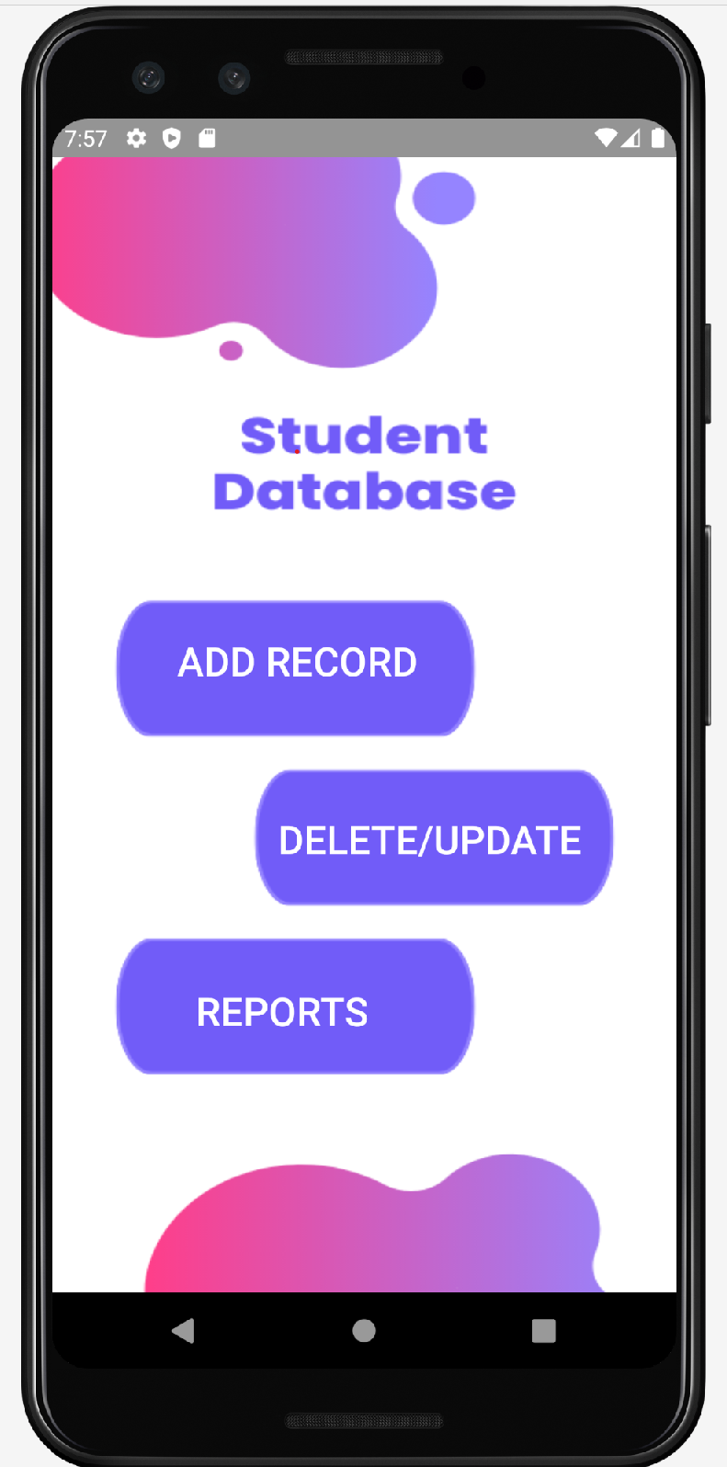

Firebase Insert Main Activity:

Java Class:

**package** com.example.smd_assignments.Assignment_6;  
  
**import** androidx.appcompat.app.AppCompatActivity;  
  
**import** android.annotation.SuppressLint;  
**import** android.content.Intent;  
**import** android.os.Bundle;  
**import** android.view.View;  
**import** android.widget.Button;  
**import** android.widget.EditText;  
**import** android.widget.Toast;  
  
**import** com.example.smd_assignments.Assignment_2.Student_Activity_Two;  
**import** com.example.smd_assignments.Assignment_2.Student_Main_Activity;  
**import** com.example.smd_assignments.R;  
**import** com.google.firebase.database.DatabaseReference;  
**import** com.google.firebase.database.FirebaseDatabase;  
  
**public class** Firebase_Insert_MainActivity **extends** AppCompatActivity {  
 EditText **edtname**,**edtdept**,**edtregno**,**edtcgpa**,**edtemail**;  
 Button **insert**;  
 FirebaseDatabase **database**;  
 DatabaseReference **reference**;  
 Button **button_back_2**;  
  
 @SuppressLint(**"MissingInflatedId"**)  
 @Override  
 **protected void** onCreate(Bundle savedInstanceState) {  
 **super**.onCreate(savedInstanceState);  
 setContentView(R.layout.***activity_firebase_insert_main***);  
  
 **edtname** = findViewById(R.id.***txtName***);  
 **edtdept** = findViewById(R.id.***txtDept***);  
 **edtregno** = findViewById(R.id.***txtRegno***);  
 **edtcgpa** = findViewById(R.id.***txtCgpa***);  
 **edtemail** = findViewById(R.id.***txtEmail***);  
  
 **database** = FirebaseDatabase.*getInstance*(**"https://smd-assignments-default-rtdb.firebaseio.com/"**);  
 **reference** = **database**.getReference().child(**"Students"**);  
  
 **insert** = findViewById(R.id.***buttonInsert***);  
  
 **insert**.setOnClickListener(**new** View.OnClickListener() {  
 @Override  
 **public void** onClick(View v) {  
 InsertIntoFirebaseDatabase();  
 }  
 });  
  
 **button_back_2** = findViewById(R.id.***back3***);  
  
 **button_back_2**.setOnClickListener(**new** View.OnClickListener() {  
 @Override  
 **public void** onClick(View view) {  
 Intent intent = **new** Intent(Firebase_Insert_MainActivity.**this**, HomePage.**class**);  
 startActivity(intent);  
 }  
 });  
 }  
  
 **public void** InsertIntoFirebaseDatabase()  
 {  
 String name = **edtname**.getText().toString();  
 String dept = **edtdept**.getText().toString();  
 String regno = **edtregno**.getText().toString();  
 String cgpa = **edtcgpa**.getText().toString();  
 String email = **edtemail**.getText().toString();  
  
 Students students = **new** Students(name,dept,regno,cgpa,email);  
 **reference**.child(regno).setValue(students);  
 Toast.*makeText*(**this**, **"Data Inserted!"**, Toast.***LENGTH_SHORT***).show();  
 }  
}

Xml File:

*<?***xml version="1.0" encoding="utf-8"***?>*<**androidx.constraintlayout.widget.ConstraintLayout xmlns:android="http://schemas.android.com/apk/res/android"  
 xmlns:app="http://schemas.android.com/apk/res-auto"  
 xmlns:tools="http://schemas.android.com/tools"  
 android:layout_width="match_parent"  
 android:layout_height="match_parent"  
 android:background="@drawable/image2_6"  
 tools:context=".Assignment_6.Firebase_Insert_MainActivity"**>  
  
 <**Button  
 android:id="@+id/back3"  
 android:layout_width="63dp"  
 android:layout_height="59dp"  
 android:layout_marginTop="44dp"  
 android:background="@drawable/baseline_arrow_back_ios_24"  
 android:contentDescription="@string/hello_first_fragment"  
 android:textColor="@color/white"  
 android:textSize="30dp"  
 app:layout_constraintEnd_toEndOf="parent"  
 app:layout_constraintHorizontal_bias="0.045"  
 app:layout_constraintStart_toStartOf="parent"  
 app:layout_constraintTop_toTopOf="parent"** />  
  
 <**EditText  
 android:id="@+id/txtName"  
 android:layout_width="194dp"  
 android:layout_height="62dp"  
 android:layout_marginTop="200dp"  
 android:ems="10"  
 android:hint="Name"  
 android:inputType="textPersonName"  
 android:textColor="@color/white"  
 android:textColorHint="@color/white"  
 android:textSize="20dp"  
 app:layout_constraintEnd_toEndOf="parent"  
 app:layout_constraintHorizontal_bias="0.566"  
 app:layout_constraintStart_toStartOf="parent"  
 app:layout_constraintTop_toTopOf="parent"** />  
  
 <**EditText  
 android:id="@+id/txtRegno"  
 android:layout_width="194dp"  
 android:layout_height="62dp"  
 android:layout_marginTop="12dp"  
 android:ems="10"  
 android:hint="Reg No"  
 android:inputType="textPersonName"  
 android:textColor="@color/white"  
 android:textColorHint="@color/white"  
 android:textSize="20dp"  
 app:layout_constraintEnd_toEndOf="parent"  
 app:layout_constraintHorizontal_bias="0.566"  
 app:layout_constraintStart_toStartOf="parent"  
 app:layout_constraintTop_toBottomOf="@+id/txtDept"** />  
  
 <**EditText  
 android:id="@+id/txtCgpa"  
 android:layout_width="194dp"  
 android:layout_height="62dp"  
 android:layout_marginTop="20dp"  
 android:ems="10"  
 android:hint="CGPA"  
 android:inputType="textPersonName"  
 android:textColor="@color/white"  
 android:textColorHint="@color/white"  
 android:textSize="20dp"  
 app:layout_constraintEnd_toEndOf="parent"  
 app:layout_constraintHorizontal_bias="0.566"  
 app:layout_constraintStart_toStartOf="parent"  
 app:layout_constraintTop_toBottomOf="@+id/txtRegno"** />  
  
 <**EditText  
 android:id="@+id/txtEmail"  
 android:layout_width="194dp"  
 android:layout_height="62dp"  
 android:layout_marginTop="20dp"  
 android:ems="10"  
 android:hint="Email"  
 android:inputType="textPersonName"  
 android:textColor="@color/white"  
 android:textColorHint="@color/white"  
 android:textSize="20dp"  
 app:layout_constraintEnd_toEndOf="parent"  
 app:layout_constraintHorizontal_bias="0.566"  
 app:layout_constraintStart_toStartOf="parent"  
 app:layout_constraintTop_toBottomOf="@+id/txtCgpa"** />  
  
 <**EditText  
 android:id="@+id/txtDept"  
 android:layout_width="194dp"  
 android:layout_height="62dp"  
 android:layout_marginTop="20dp"  
 android:ems="10"  
 android:hint="Dept"  
 android:inputType="textPersonName"  
 android:textColor="@color/white"  
 android:textColorHint="@color/white"  
 android:textSize="20dp"  
 app:layout_constraintEnd_toEndOf="parent"  
 app:layout_constraintHorizontal_bias="0.566"  
 app:layout_constraintStart_toStartOf="parent"  
 app:layout_constraintTop_toBottomOf="@+id/txtName"** />  
  
 <**Button  
 android:id="@+id/buttonInsert"  
 android:layout_width="132dp"  
 android:layout_height="79dp"  
 android:layout_marginTop="60dp"  
 android:background="#00000000"  
 android:text="Insert"  
 android:textColor="@color/white"  
 android:textSize="30dp"  
 app:layout_constraintEnd_toEndOf="parent"  
 app:layout_constraintHorizontal_bias="0.318"  
 app:layout_constraintStart_toStartOf="parent"  
 app:layout_constraintTop_toBottomOf="@+id/txtEmail"** />  
  
</**androidx.constraintlayout.widget.ConstraintLayout**>

Student Java Class:

**package** com.example.smd_assignments.Assignment_6;  
  
**public class** Students {  
 String **name**;  
 String **dept**;  
 String **regno**;  
 String **cgpa**;  
 String **email**;  
  
 **public** Students() {  
 }  
  
 **public** Students(String name, String dept, String regno, String cgpa, String email) {  
 **this**.**name** = name;  
 **this**.**dept** = dept;  
 **this**.**regno** = regno;  
 **this**.**cgpa** = cgpa;  
 **this**.**email** = email;  
 }  
  
 **public** String getName() {  
 **return name**;  
 }  
  
 **public void** setName(String name) {  
 **this**.**name** = name;  
 }  
  
 **public** String getDept() {  
 **return dept**;  
 }  
  
 **public void** setDept(String dept) {  
 **this**.**dept** = dept;  
 }  
  
 **public** String getRegno() {  
 **return regno**;  
 }  
  
 **public void** setRegno(String regno) {  
 **this**.**regno** = regno;  
 }  
  
 **public** String getCgpa() {  
 **return cgpa**;  
 }  
  
 **public void** setCgpa(String cgpa) {  
 **this**.**cgpa** = cgpa;  
 }  
  
 **public** String getEmail() {  
 **return email**;  
 }  
  
 **public void** setEmail(String email) {  
 **this**.**email** = email;  
 }  
}

Output:

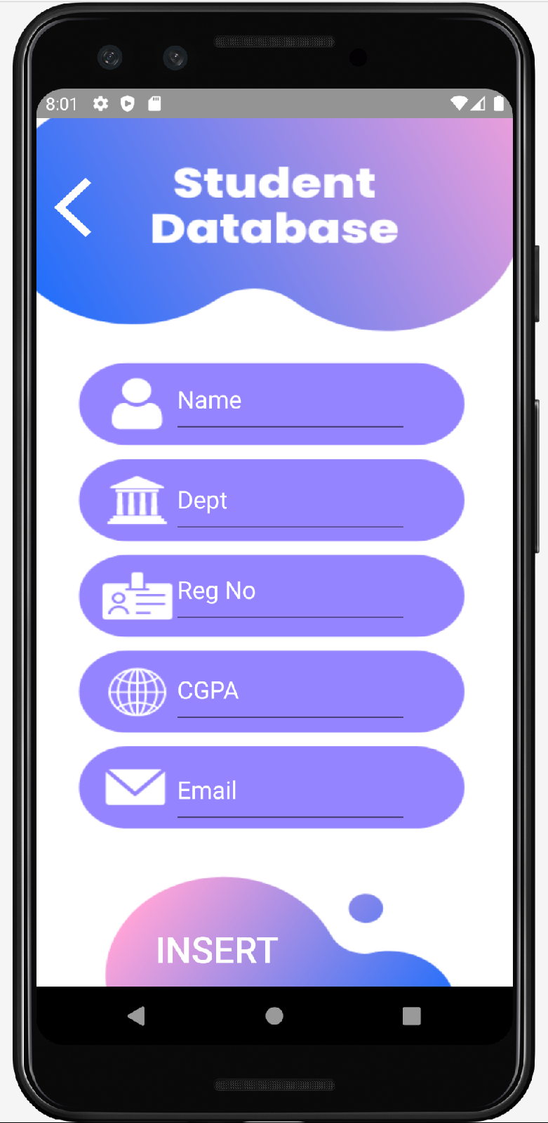

Update & Delete Main Activity:

Java Class:

**package** com.example.smd_assignments.Assignment_6;  
  
**import** androidx.annotation.NonNull;  
**import** androidx.appcompat.app.AppCompatActivity;  
  
**import** android.annotation.SuppressLint;  
**import** android.content.Intent;  
**import** android.os.Bundle;  
**import** android.view.View;  
**import** android.widget.Button;  
**import** android.widget.EditText;  
  
**import** com.example.smd_assignments.R;  
**import** com.google.android.gms.tasks.Task;  
**import** com.google.firebase.database.DataSnapshot;  
**import** com.google.firebase.database.DatabaseError;  
**import** com.google.firebase.database.DatabaseReference;  
**import** com.google.firebase.database.FirebaseDatabase;  
**import** com.google.firebase.database.ValueEventListener;  
  
**import** java.util.HashMap;  
**import** java.util.Map;  
  
**public class** Firebase_Search_Delete_MainActivity **extends** AppCompatActivity {  
  
 EditText **number**;  
 EditText **edtname**;  
 EditText **edtdept**;  
 EditText **edtregno**;  
 EditText **edtcgpa**;  
 EditText **edtemail**;  
 Button **delete**, **search**, **update**;  
 FirebaseDatabase **database**;  
 DatabaseReference **reference**;  
 Task<Void> **reference1**;  
 Button **button_back_2**;  
  
 @SuppressLint(**"MissingInflatedId"**)  
 @Override  
 **protected void** onCreate(Bundle savedInstanceState) {  
 **super**.onCreate(savedInstanceState);  
 setContentView(R.layout.***activity_firebase_search_delete_main***);  
  
 **number** = findViewById(R.id.***txtRegNoSearch***);  
 **delete** = findViewById(R.id.***buttonDelete***);  
 **search** = findViewById(R.id.***buttonSearch***);  
 **update** = findViewById(R.id.***buttonUpdate***);  
 **edtname** = findViewById(R.id.***txtsetname***);  
 **edtdept** = findViewById(R.id.***txtsetdept***);  
 **edtcgpa** = findViewById(R.id.***txtsetcgpa***);  
 **edtemail** = findViewById(R.id.***txtsetemail***);  
  
 **database** = FirebaseDatabase.*getInstance*(**"https://smd-assignments-default-rtdb.firebaseio.com/"**);  
 **delete**.setOnClickListener(**new** View.OnClickListener() {  
 @Override  
 **public void** onClick(View v) {  
 String Search = **number**.getText().toString();  
 DeleteIntoFirebaseDatabase(Search);  
 }  
 });  
  
 **search**.setOnClickListener(**new** View.OnClickListener() {  
 @Override  
 **public void** onClick(View v) {  
 String Search = **number**.getText().toString();  
 SearchIntoFirebaseDatabase(Search);  
 }  
 });  
  
 **update**.setOnClickListener(**new** View.OnClickListener() {  
 @Override  
 **public void** onClick(View v) {  
 String Search = **number**.getText().toString();  
 UpdateIntoFirebaseDatabase(Search);  
 }  
 });  
  
 **button_back_2** = findViewById(R.id.***back4***);  
  
 **button_back_2**.setOnClickListener(**new** View.OnClickListener() {  
 @Override  
 **public void** onClick(View view) {  
 Intent intent = **new** Intent(Firebase_Search_Delete_MainActivity.**this**, HomePage.**class**);  
 startActivity(intent);  
 }  
 });  
 }  
  
 **public void** DeleteIntoFirebaseDatabase(String id)  
 {  
 **reference** = **database**.getReference().child(**"Students"**).child(id);  
 **reference**.removeValue();  
 }  
  
 **public void** SearchIntoFirebaseDatabase(String id)  
 {  
 **reference** = **database**.getReference().child(**"Students"**).child(id);  
 **reference**.addValueEventListener(**new** ValueEventListener() {  
 @Override  
 **public void** onDataChange(@NonNull DataSnapshot datasnapshot) {  
  
 String name = datasnapshot.child(**"name"**).getValue().toString();  
 String dept = datasnapshot.child(**"dept"**).getValue().toString();  
 String cgpa = datasnapshot.child(**"cgpa"**).getValue().toString();  
 String email = datasnapshot.child(**"email"**).getValue().toString();  
  
 **edtname**.setText(name);  
 **edtdept**.setText(dept);  
 **edtcgpa**.setText(cgpa);  
 **edtemail**.setText(email);  
 }  
  
 @Override  
 **public void** onCancelled(@NonNull DatabaseError error) {  
  
 }  
 });  
 }  
  
 **public void** UpdateIntoFirebaseDatabase(String id)  
 {  
 Map<String, Object> map = **new** HashMap<>();  
 map.put(**"name"**,**edtname**.getText().toString());  
 map.put(**"dept"**,**edtdept**.getText().toString());  
 map.put(**"cgpa"**,**edtcgpa**.getText().toString());  
 map.put(**"email"**,**edtemail**.getText().toString());  
 **reference1** = **database**.getReference().child(**"Students"**).child(id).updateChildren(map);  
 }  
}

Xml File:

*<?***xml version="1.0" encoding="utf-8"***?>*<**androidx.constraintlayout.widget.ConstraintLayout xmlns:android="http://schemas.android.com/apk/res/android"  
 xmlns:app="http://schemas.android.com/apk/res-auto"  
 xmlns:tools="http://schemas.android.com/tools"  
 android:layout_width="match_parent"  
 android:layout_height="match_parent"  
 android:background="@drawable/image3_6"  
 tools:context=".Assignment_6.Firebase_Search_Delete_MainActivity"**>  
  
 <**Button  
 android:id="@+id/back4"  
 android:layout_width="51dp"  
 android:layout_height="52dp"  
 android:layout_marginTop="4dp"  
 android:background="@drawable/baseline_arrow_back_ios_24"  
 android:contentDescription="@string/hello_first_fragment"  
 android:textColor="@color/white"  
 android:textSize="30dp"  
 app:layout_constraintEnd_toEndOf="parent"  
 app:layout_constraintHorizontal_bias="0.044"  
 app:layout_constraintStart_toStartOf="parent"  
 app:layout_constraintTop_toTopOf="parent"** />  
  
 <**Button  
 android:id="@+id/buttonSearch"  
 android:layout_width="60dp"  
 android:layout_height="57dp"  
 android:layout_marginTop="172dp"  
 android:layout_marginEnd="48dp"  
 android:background="@drawable/baseline_person_search_24"  
 android:contentDescription="@string/hello_first_fragment"  
 android:textColor="@color/white"  
 android:textSize="30dp"  
 app:layout_constraintEnd_toEndOf="parent"  
 app:layout_constraintTop_toTopOf="parent"** />  
  
 <**EditText  
 android:id="@+id/txtRegNoSearch"  
 android:layout_width="232dp"  
 android:layout_height="66dp"  
 android:layout_marginTop="160dp"  
 android:ems="10"  
 android:hint="Reg No"  
 android:textSize="30dp"  
 android:textColor="@color/white"  
 android:textColorHint="@color/white"  
 android:inputType="textPersonName"  
 app:layout_constraintEnd_toStartOf="@+id/buttonSearch"  
 app:layout_constraintHorizontal_bias="0.676"  
 app:layout_constraintStart_toStartOf="parent"  
 app:layout_constraintTop_toTopOf="parent"** />  
  
 <**Button  
 android:id="@+id/buttonDelete"  
 android:layout_width="151dp"  
 android:layout_height="63dp"  
 android:layout_marginEnd="28dp"  
 android:layout_marginBottom="36dp"  
 android:background="#00000000"  
 android:text="Delete"  
 android:textColor="@color/white"  
 android:textSize="25dp"  
 app:layout_constraintBottom_toBottomOf="parent"  
 app:layout_constraintEnd_toEndOf="parent"** />  
  
 <**EditText  
 android:id="@+id/txtsetname"  
 android:layout_width="300dp"  
 android:layout_height="54dp"  
 android:layout_marginTop="56dp"  
 android:ems="10"  
 android:textColorHint="#887AE3"  
 android:textSize="20dp"  
 android:textColor="#887AE3"  
 android:hint="Name"  
 android:inputType="textPersonName"  
 android:minHeight="48dp"  
 app:layout_constraintEnd_toEndOf="parent"  
 app:layout_constraintHorizontal_bias="0.495"  
 app:layout_constraintStart_toStartOf="parent"  
 app:layout_constraintTop_toBottomOf="@+id/txtRegNoSearch"** />  
  
 <**EditText  
 android:id="@+id/txtsetdept"  
 android:layout_width="300dp"  
 android:layout_height="54dp"  
 android:layout_marginTop="28dp"  
 android:ems="10"  
 android:hint="dept"  
 android:inputType="textPersonName"  
 android:minHeight="48dp"  
 android:textColor="#887AE3"  
 android:textColorHint="#887AE3"  
 android:textSize="20dp"  
 app:layout_constraintEnd_toEndOf="parent"  
 app:layout_constraintHorizontal_bias="0.495"  
 app:layout_constraintStart_toStartOf="parent"  
 app:layout_constraintTop_toBottomOf="@+id/txtsetname"** />  
  
 <**EditText  
 android:id="@+id/txtsetcgpa"  
 android:layout_width="296dp"  
 android:layout_height="58dp"  
 android:layout_marginTop="28dp"  
 android:ems="10"  
 android:hint="cgpa"  
 android:inputType="textPersonName"  
 android:minHeight="48dp"  
 android:textColor="#887AE3"  
 android:textColorHint="#887AE3"  
 android:textSize="20dp"  
 app:layout_constraintEnd_toEndOf="parent"  
 app:layout_constraintHorizontal_bias="0.495"  
 app:layout_constraintStart_toStartOf="parent"  
 app:layout_constraintTop_toBottomOf="@+id/txtsetdept"** />  
  
 <**EditText  
 android:id="@+id/txtsetemail"  
 android:layout_width="300dp"  
 android:layout_height="54dp"  
 android:layout_marginTop="28dp"  
 android:ems="10"  
 android:hint="email"  
 android:inputType="textPersonName"  
 android:minHeight="48dp"  
 android:textColor="#887AE3"  
 android:textColorHint="#887AE3"  
 android:textSize="20dp"  
 app:layout_constraintEnd_toEndOf="parent"  
 app:layout_constraintHorizontal_bias="0.495"  
 app:layout_constraintStart_toStartOf="parent"  
 app:layout_constraintTop_toBottomOf="@+id/txtsetcgpa"** />  
  
 <**Button  
 android:id="@+id/buttonUpdate"  
 android:layout_width="146dp"  
 android:layout_height="69dp"  
 android:layout_marginBottom="36dp"  
 android:background="#00000000"  
 android:text="Update"  
 android:textColor="@color/white"  
 android:textSize="25dp"  
 app:layout_constraintBottom_toBottomOf="parent"  
 app:layout_constraintEnd_toStartOf="@+id/buttonDelete"  
 app:layout_constraintHorizontal_bias="0.493"  
 app:layout_constraintStart_toStartOf="parent"** />  
</**androidx.constraintlayout.widget.ConstraintLayout**>

Output:

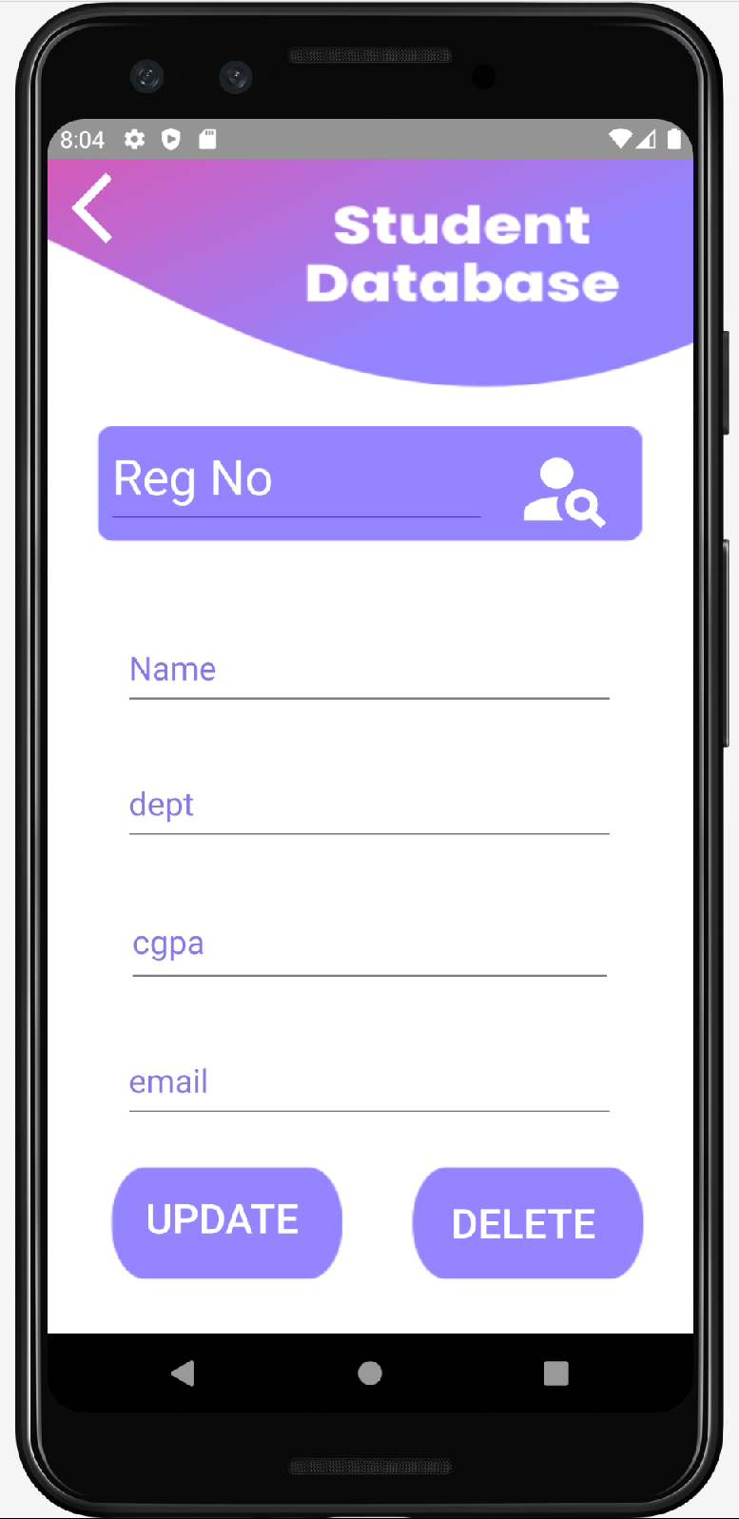

Report Main Activity:

Java Class:

**package** com.example.smd_assignments.Assignment_6;  
  
**import** androidx.appcompat.app.AppCompatActivity;  
  
**import** android.content.Intent;  
**import** android.os.Bundle;  
**import** android.view.View;  
**import** android.widget.Button;  
  
**import** com.example.smd_assignments.R;  
  
**public class** Firebase_Reports_MainActivity **extends** AppCompatActivity {  
  
 Button **Greater**, **Less**, **deptcheck**;  
  
 @Override  
 **protected void** onCreate(Bundle savedInstanceState) {  
 **super**.onCreate(savedInstanceState);  
 setContentView(R.layout.***activity_firebase_reports_main***);  
  
 **Greater** = findViewById(R.id.***Greater***);  
 **Less** = findViewById(R.id.***Less***);  
 **deptcheck** = findViewById(R.id.***DeptCheck***);  
  
 **Greater**.setOnClickListener(**new** View.OnClickListener() {  
 @Override  
 **public void** onClick(View v) {  
 Intent intent = **new** Intent(getApplicationContext(),Firebase_Search_Greater_MainActivity.**class**);  
 startActivity(intent);  
 }  
 });  
  
 **Less**.setOnClickListener(**new** View.OnClickListener() {  
 @Override  
 **public void** onClick(View v) {  
 Intent intent = **new** Intent(getApplicationContext(),Firebase_Search_Less_MainActivity.**class**);  
 startActivity(intent);  
 }  
 });  
  
 **deptcheck**.setOnClickListener(**new** View.OnClickListener() {  
 @Override  
 **public void** onClick(View v) {  
 Intent intent = **new** Intent(getApplicationContext(),Firebase_Search_Dept_MainActivity.**class**);  
 startActivity(intent);  
 }  
 });  
 }  
}

Xml File:

*<?***xml version="1.0" encoding="utf-8"***?>*<**androidx.constraintlayout.widget.ConstraintLayout xmlns:android="http://schemas.android.com/apk/res/android"  
 xmlns:app="http://schemas.android.com/apk/res-auto"  
 xmlns:tools="http://schemas.android.com/tools"  
 android:layout_width="match_parent"  
 android:layout_height="match_parent"  
 android:background="@drawable/image1_6"  
 tools:context=".Assignment_6.Firebase_Reports_MainActivity"**>  
  
 <**Button  
 android:id="@+id/Greater"  
 android:layout_width="204dp"  
 android:layout_height="73dp"  
 android:layout_marginTop="280dp"  
 android:background="#00000000"  
 android:text="CGPA greater\n than 3.0"  
 android:textColor="@color/white"  
 android:textSize="25dp"  
 app:layout_constraintEnd_toEndOf="parent"  
 app:layout_constraintHorizontal_bias="0.28"  
 app:layout_constraintStart_toStartOf="parent"  
 app:layout_constraintTop_toTopOf="parent"** />  
  
 <**Button  
 android:id="@+id/Less"  
 android:layout_width="204dp"  
 android:layout_height="73dp"  
 android:layout_marginTop="392dp"  
 android:background="#00000000"  
 android:text="CGPA LESS\nTHAN 1.99"  
 android:textColor="@color/white"  
 android:textSize="25dp"  
 app:layout_constraintEnd_toEndOf="parent"  
 app:layout_constraintHorizontal_bias="0.719"  
 app:layout_constraintStart_toStartOf="parent"  
 app:layout_constraintTop_toTopOf="parent"** />  
  
 <**Button  
 android:id="@+id/DeptCheck"  
 android:layout_width="230dp"  
 android:layout_height="107dp"  
 android:layout_marginTop="484dp"  
 android:background="#00000000"  
 android:text="SE/CS Department report"  
 android:textColor="@color/white"  
 android:textSize="20dp"  
 app:layout_constraintEnd_toEndOf="parent"  
 app:layout_constraintHorizontal_bias="0.237"  
 app:layout_constraintStart_toStartOf="parent"  
 app:layout_constraintTop_toTopOf="parent"** />  
  
</**androidx.constraintlayout.widget.ConstraintLayout**>

Output:

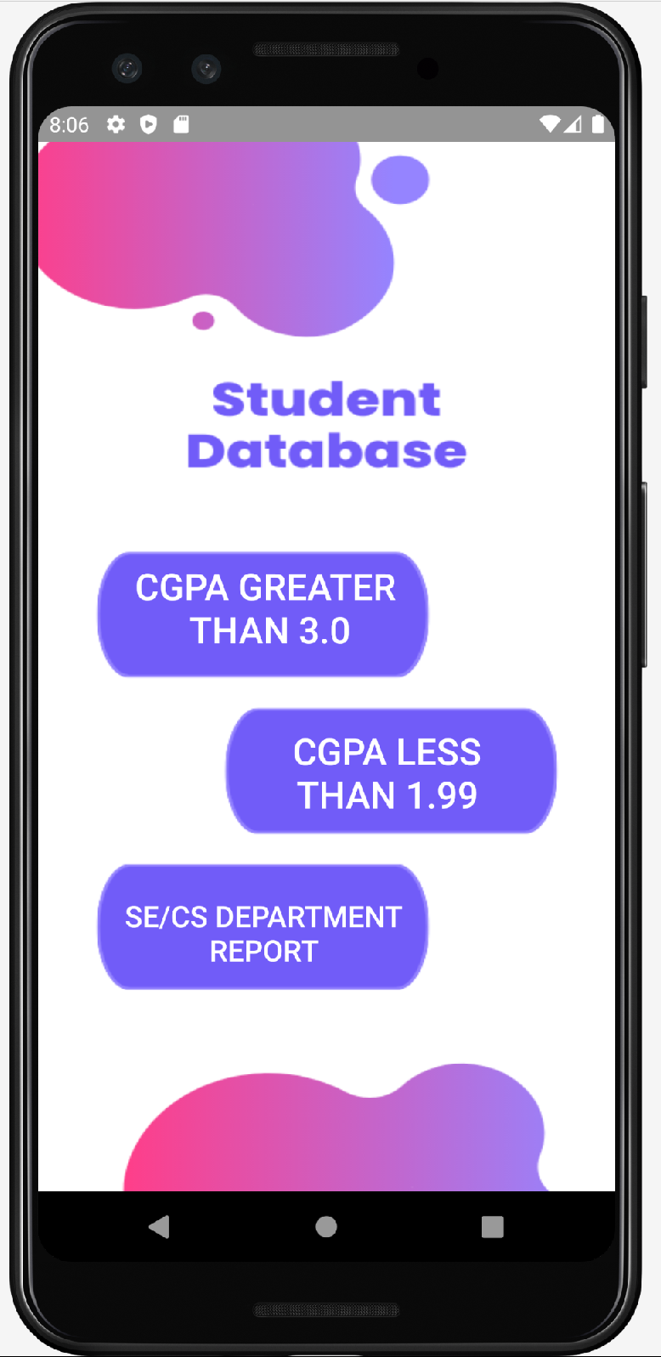

CGPA Greater Than 3 Main Activity:

Java Class:

**package** com.example.smd_assignments.Assignment_6;  
  
**import** androidx.annotation.NonNull;  
**import** androidx.appcompat.app.AppCompatActivity;  
**import** androidx.recyclerview.widget.LinearLayoutManager;  
**import** androidx.recyclerview.widget.RecyclerView;  
  
**import** android.annotation.SuppressLint;  
**import** android.content.Intent;  
**import** android.os.Bundle;  
**import** android.view.View;  
**import** android.widget.Button;  
**import** android.widget.TextView;  
  
**import** com.example.smd_assignments.R;  
**import** com.google.firebase.database.DataSnapshot;  
**import** com.google.firebase.database.DatabaseError;  
**import** com.google.firebase.database.DatabaseReference;  
**import** com.google.firebase.database.FirebaseDatabase;  
**import** com.google.firebase.database.ValueEventListener;  
  
**import** java.util.ArrayList;  
  
**public class** Firebase_Search_Greater_MainActivity **extends** AppCompatActivity {  
 FirebaseDatabase **database**;  
 DatabaseReference **reference**;  
 TextView **textView1**;  
  
 ArrayList<Students> **student_ArrayList**;  
 RecyclerView **recyclerView**;  
 FireBase_Adapter **adapter**;  
  
 Button **button_back_2**;  
  
 @SuppressLint(**"MissingInflatedId"**)  
 @Override  
 **protected void** onCreate(Bundle savedInstanceState) {  
 **super**.onCreate(savedInstanceState);  
 setContentView(R.layout.***activity_firebase_search_greater_main***);  
  
 **recyclerView** = findViewById(R.id.***firebaserecyclerview***);  
 LinearLayoutManager linearLayoutManager = **new** LinearLayoutManager(**this**);  
 **recyclerView**.setLayoutManager(linearLayoutManager);  
 **recyclerView**.setHasFixedSize(**true**);  
  
 **database** = FirebaseDatabase.*getInstance*(**"https://smd-assignments-default-rtdb.firebaseio.com/"**);  
 **reference** = **database**.getReference(**"Students"**);  
  
 **student_ArrayList** = **new** ArrayList<>();  
 ReadDataFromFirebase();  
  
 **button_back_2** = findViewById(R.id.***back5***);  
  
 **button_back_2**.setOnClickListener(**new** View.OnClickListener() {  
 @Override  
 **public void** onClick(View view) {  
 Intent intent = **new** Intent(Firebase_Search_Greater_MainActivity.**this**, HomePage.**class**);  
 startActivity(intent);  
 }  
 });  
 }  
  
 **private void** ReadDataFromFirebase() {  
 **reference**.addValueEventListener(**new** ValueEventListener() {  
 @Override  
 **public void** onDataChange(@NonNull DataSnapshot datasnapshot) {  
 **for** (DataSnapshot snapshot1 : datasnapshot.getChildren()) {  
 Students student = **new** Students();  
 student.setName(snapshot1.child(**"name"**).getValue().toString());  
 student.setDept(snapshot1.child(**"dept"**).getValue().toString());  
 student.setCgpa(snapshot1.child(**"cgpa"**).getValue().toString());  
 String cgpa = snapshot1.child(**"cgpa"**).getValue().toString();  
 **float** number = Float.*parseFloat*(cgpa);  
 **if**(number >= 3.0) {  
 **student_ArrayList**.add(student);  
 }  
 }  
 **adapter** = **new** FireBase_Adapter(**student_ArrayList**,getApplicationContext());  
 **recyclerView**.setAdapter(**adapter**);  
 **adapter**.notifyDataSetChanged();  
 }  
  
 @Override  
 **public void** onCancelled(@NonNull DatabaseError error) {  
  
 }  
 });  
 }  
}

Xml File:

*<?***xml version="1.0" encoding="utf-8"***?>*<**androidx.constraintlayout.widget.ConstraintLayout xmlns:android="http://schemas.android.com/apk/res/android"  
 xmlns:app="http://schemas.android.com/apk/res-auto"  
 xmlns:tools="http://schemas.android.com/tools"  
 android:layout_width="match_parent"  
 android:layout_height="match_parent"  
 android:background="@drawable/image4_6"  
 tools:context=".Assignment_6.Firebase_Search_Greater_MainActivity"**>  
  
 <**Button  
 android:id="@+id/back5"  
 android:layout_width="72dp"  
 android:layout_height="73dp"  
 android:layout_marginTop="24dp"  
 android:background="@drawable/baseline_arrow_back_ios_24"  
 android:contentDescription="@string/hello_first_fragment"  
 android:textColor="@color/white"  
 android:textSize="30dp"  
 app:layout_constraintEnd_toEndOf="parent"  
 app:layout_constraintHorizontal_bias="0.094"  
 app:layout_constraintStart_toStartOf="parent"  
 app:layout_constraintTop_toTopOf="parent"** />  
  
 <**androidx.recyclerview.widget.RecyclerView  
 android:id="@+id/firebaserecyclerview"  
 android:layout_width="292dp"  
 android:layout_height="528dp"  
 app:layout_constraintBottom_toBottomOf="parent"  
 app:layout_constraintEnd_toEndOf="parent"  
 app:layout_constraintHorizontal_bias="0.495"  
 app:layout_constraintStart_toStartOf="parent"  
 app:layout_constraintTop_toTopOf="parent"  
 app:layout_constraintVertical_bias="0.832"** />  
</**androidx.constraintlayout.widget.ConstraintLayout**>

Firebase Adapter Java Class:

**package** com.example.smd_assignments.Assignment_6;  
  
**import** android.content.Context;  
**import** android.view.LayoutInflater;  
**import** android.view.View;  
**import** android.view.ViewGroup;  
**import** android.widget.TextView;  
**import** android.widget.Toast;  
  
**import** androidx.annotation.NonNull;  
**import** androidx.recyclerview.widget.RecyclerView;  
  
**import** com.example.smd_assignments.R;  
  
**import** java.util.ArrayList;  
  
**public class** FireBase_Adapter **extends** RecyclerView.Adapter<FireBase_Adapter.ViewHolder>{  
 ArrayList<Students> **studentArrayList**;  
 Context **context**;  
  
 **public** FireBase_Adapter(ArrayList<Students> studentArrayList, Context context) {  
 **this**.**studentArrayList** = studentArrayList;  
 **this**.**context** = context;  
 }  
  
 @NonNull  
 @Override  
 **public** ViewHolder onCreateViewHolder(@NonNull ViewGroup parent, **int** viewType) {  
 View view = LayoutInflater.*from*(parent.getContext()).inflate(R.layout.***message_list***,parent,**false**);  
 **return new** ViewHolder(view);  
 }  
  
 @Override  
 **public void** onBindViewHolder(@NonNull ViewHolder holder, **int** position) {  
 holder.**name**.setText(**studentArrayList**.get(position).getName());  
 holder.**dept**.setText(**studentArrayList**.get(position).getDept());  
 holder.**cgpa**.setText(**studentArrayList**.get(position).getCgpa());  
 }  
  
 @Override  
 **public int** getItemCount() {  
 **return studentArrayList**.size();  
 }  
  
 **public class** ViewHolder **extends** RecyclerView.ViewHolder  
 {  
 TextView **name**, **dept**, **cgpa**;  
  
 **public** ViewHolder(@NonNull View view) {  
 **super**(view);  
 **name** = view.findViewById(R.id.***firebasename***);  
 **dept** = view.findViewById(R.id.***firebasedept***);  
 **cgpa** = view.findViewById(R.id.***firebasecgpa***);  
 }  
 }  
}

Recycler View Layout:

*<?***xml version="1.0" encoding="utf-8"***?>*<**androidx.constraintlayout.widget.ConstraintLayout xmlns:android="http://schemas.android.com/apk/res/android"  
 xmlns:app="http://schemas.android.com/apk/res-auto"  
 xmlns:tools="http://schemas.android.com/tools"  
 android:layout_width="match_parent"  
 android:layout_height="100dp"**>  
  
 <**TextView  
 android:id="@+id/firebasename"  
 android:layout_width="106dp"  
 android:layout_height="45dp"  
 android:layout_marginTop="28dp"  
 android:text="textviewsdf12"  
 android:textColor="@color/white"  
 android:textSize="20dp"  
 app:layout_constraintEnd_toEndOf="parent"  
 app:layout_constraintHorizontal_bias="0.052"  
 app:layout_constraintStart_toStartOf="parent"  
 app:layout_constraintTop_toTopOf="parent"** />  
  
 <**TextView  
 android:id="@+id/firebasedept"  
 android:layout_width="106dp"  
 android:layout_height="45dp"  
 android:layout_marginTop="28dp"  
 android:text="textviewsdf12"  
 android:textColor="@color/white"  
 android:textSize="20dp"  
 app:layout_constraintEnd_toStartOf="@+id/firebasecgpa"  
 app:layout_constraintHorizontal_bias="0.394"  
 app:layout_constraintStart_toEndOf="@+id/firebasename"  
 app:layout_constraintTop_toTopOf="parent"** />  
  
 <**TextView  
 android:id="@+id/firebasecgpa"  
 android:layout_width="106dp"  
 android:layout_height="45dp"  
 android:layout_marginStart="248dp"  
 android:text="textviewsdf12"  
 android:textColor="@color/white"  
 android:textSize="20dp"  
 app:layout_constraintBottom_toBottomOf="parent"  
 app:layout_constraintStart_toStartOf="@+id/firebasename"  
 app:layout_constraintTop_toTopOf="parent"  
 app:layout_constraintVertical_bias="0.509"** />  
  
 <**LinearLayout  
 android:layout_width="374dp"  
 android:layout_height="0dp"  
 android:layout_marginBottom="16dp"  
 android:background="@color/black"  
 android:orientation="horizontal"  
 app:layout_constraintBottom_toBottomOf="parent"  
 app:layout_constraintEnd_toEndOf="parent"  
 app:layout_constraintHorizontal_bias="0.567"  
 app:layout_constraintStart_toStartOf="parent"**></**LinearLayout**>  
  
</**androidx.constraintlayout.widget.ConstraintLayout**>

Output:

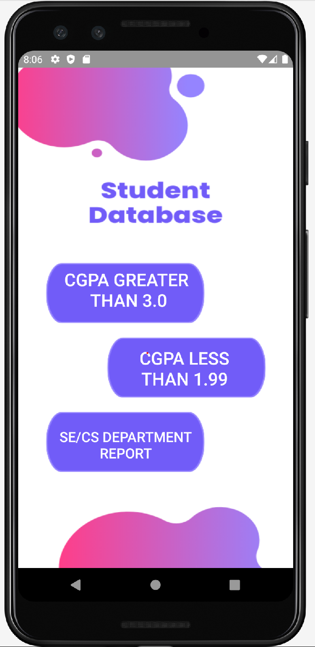

CGPA Greater Than 3 Main Activity:

Java Class:

**package** com.example.smd_assignments.Assignment_6;  
  
**import** androidx.annotation.NonNull;  
**import** androidx.appcompat.app.AppCompatActivity;  
**import** androidx.recyclerview.widget.LinearLayoutManager;  
**import** androidx.recyclerview.widget.RecyclerView;  
  
**import** android.annotation.SuppressLint;  
**import** android.content.Intent;  
**import** android.os.Bundle;  
**import** android.view.View;  
**import** android.widget.Button;  
**import** android.widget.TextView;  
  
**import** com.example.smd_assignments.R;  
**import** com.google.firebase.database.DataSnapshot;  
**import** com.google.firebase.database.DatabaseError;  
**import** com.google.firebase.database.DatabaseReference;  
**import** com.google.firebase.database.FirebaseDatabase;  
**import** com.google.firebase.database.ValueEventListener;  
  
**import** java.util.ArrayList;  
  
**public class** Firebase_Search_Less_MainActivity **extends** AppCompatActivity {  
 FirebaseDatabase **database**;  
 DatabaseReference **reference**;  
 TextView **textView1**;  
  
 ArrayList<Students> **student_ArrayList**;  
 RecyclerView **recyclerView**;  
 FireBase_Adapter **adapter**;  
  
 Button **button_back_2**;  
  
 @SuppressLint(**"MissingInflatedId"**)  
 @Override  
 **protected void** onCreate(Bundle savedInstanceState) {  
 **super**.onCreate(savedInstanceState);  
 setContentView(R.layout.***activity_firebase_search_less_main***);  
  
 **recyclerView** = findViewById(R.id.***firebaserecyclerview***);  
 LinearLayoutManager linearLayoutManager = **new** LinearLayoutManager(**this**);  
 **recyclerView**.setLayoutManager(linearLayoutManager);  
 **recyclerView**.setHasFixedSize(**true**);  
  
 **database** = FirebaseDatabase.*getInstance*(**"https://smd-assignments-default-rtdb.firebaseio.com/"**);  
 **reference** = **database**.getReference(**"Students"**);  
  
 **student_ArrayList** = **new** ArrayList<>();  
 ReadDataFromFirebase();  
  
 **button_back_2** = findViewById(R.id.***back6***);  
  
 **button_back_2**.setOnClickListener(**new** View.OnClickListener() {  
 @Override  
 **public void** onClick(View view) {  
 Intent intent = **new** Intent(Firebase_Search_Less_MainActivity.**this**, HomePage.**class**);  
 startActivity(intent);  
 }  
 });  
 }  
  
 **private void** ReadDataFromFirebase() {  
 **reference**.addValueEventListener(**new** ValueEventListener() {  
 @Override  
 **public void** onDataChange(@NonNull DataSnapshot datasnapshot) {  
 **for** (DataSnapshot snapshot1 : datasnapshot.getChildren()) {  
 Students student = **new** Students();  
 student.setName(snapshot1.child(**"name"**).getValue().toString());  
 student.setDept(snapshot1.child(**"dept"**).getValue().toString());  
 student.setCgpa(snapshot1.child(**"cgpa"**).getValue().toString());  
 String cgpa = snapshot1.child(**"cgpa"**).getValue().toString();  
 **float** number = Float.*parseFloat*(cgpa);  
 **if**(number <= 1.99) {  
 **student_ArrayList**.add(student);  
 }  
 }  
 **adapter** = **new** FireBase_Adapter(**student_ArrayList**,getApplicationContext());  
 **recyclerView**.setAdapter(**adapter**);  
 **adapter**.notifyDataSetChanged();  
 }  
  
 @Override  
 **public void** onCancelled(@NonNull DatabaseError error) {  
  
 }  
 });  
 }  
}

Xml File:

*<?***xml version="1.0" encoding="utf-8"***?>*<**androidx.constraintlayout.widget.ConstraintLayout xmlns:android="http://schemas.android.com/apk/res/android"  
 xmlns:app="http://schemas.android.com/apk/res-auto"  
 xmlns:tools="http://schemas.android.com/tools"  
 android:layout_width="match_parent"  
 android:layout_height="match_parent"  
 android:background="@drawable/image4_6"  
 tools:context=".Assignment_6.Firebase_Search_Less_MainActivity"**>  
  
  
 <**Button  
 android:id="@+id/back6"  
 android:layout_width="72dp"  
 android:layout_height="73dp"  
 android:layout_marginTop="24dp"  
 android:background="@drawable/baseline_arrow_back_ios_24"  
 android:contentDescription="@string/hello_first_fragment"  
 android:textColor="@color/white"  
 android:textSize="30dp"  
 app:layout_constraintEnd_toEndOf="parent"  
 app:layout_constraintHorizontal_bias="0.094"  
 app:layout_constraintStart_toStartOf="parent"  
 app:layout_constraintTop_toTopOf="parent"** />  
  
 <**androidx.recyclerview.widget.RecyclerView  
 android:id="@+id/firebaserecyclerview"  
 android:layout_width="292dp"  
 android:layout_height="528dp"  
 app:layout_constraintBottom_toBottomOf="parent"  
 app:layout_constraintEnd_toEndOf="parent"  
 app:layout_constraintHorizontal_bias="0.495"  
 app:layout_constraintStart_toStartOf="parent"  
 app:layout_constraintTop_toTopOf="parent"  
 app:layout_constraintVertical_bias="0.827"** />  
  
</**androidx.constraintlayout.widget.ConstraintLayout**>

Output:

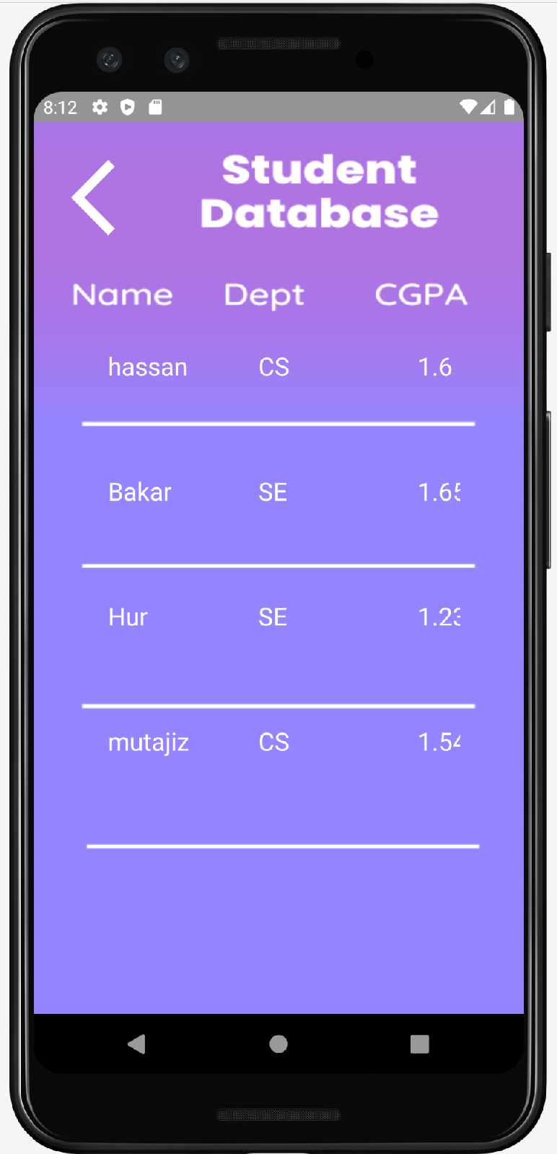

Dept CS/SE Main Activity :

Java Class:

**package** com.example.smd_assignments.Assignment_6;  
  
**import** androidx.annotation.NonNull;  
**import** androidx.appcompat.app.AppCompatActivity;  
**import** androidx.recyclerview.widget.LinearLayoutManager;  
**import** androidx.recyclerview.widget.RecyclerView;  
  
**import** android.annotation.SuppressLint;  
**import** android.os.Bundle;  
**import** android.widget.TextView;  
  
**import** com.example.smd_assignments.R;  
**import** com.google.firebase.database.DataSnapshot;  
**import** com.google.firebase.database.DatabaseError;  
**import** com.google.firebase.database.DatabaseReference;  
**import** com.google.firebase.database.FirebaseDatabase;  
**import** com.google.firebase.database.ValueEventListener;  
  
**import** java.util.ArrayList;  
  
**public class** Firebase_Search_Dept_MainActivity **extends** AppCompatActivity {  
 FirebaseDatabase **database**;  
 DatabaseReference **reference**;  
 TextView **textView1**;  
  
 ArrayList<Students> **student_ArrayList**, **student_ArrayList1**;  
 RecyclerView **recyclerView**, **recyclerView1**;  
 FireBase_Adapter **adapter**, **adapter1**;  
  
 @SuppressLint(**"MissingInflatedId"**)  
 @Override  
 **protected void** onCreate(Bundle savedInstanceState) {  
 **super**.onCreate(savedInstanceState);  
 setContentView(R.layout.***activity_firebase_search_dept_main***);  
  
 **recyclerView** = findViewById(R.id.***firebaserecyclerview***);  
 **recyclerView1** = findViewById(R.id.***firebaserecyclerview1***);  
 LinearLayoutManager linearLayoutManager = **new** LinearLayoutManager(**this**);  
 **recyclerView**.setLayoutManager(linearLayoutManager);  
 **recyclerView**.setHasFixedSize(**true**);  
  
 LinearLayoutManager linearLayoutManager1 = **new** LinearLayoutManager(**this**);  
 **recyclerView1**.setLayoutManager(linearLayoutManager1);  
 **recyclerView1**.setHasFixedSize(**true**);  
  
 **database** = FirebaseDatabase.*getInstance*(**"https://smd-assignments-default-rtdb.firebaseio.com/"**);  
 **reference** = **database**.getReference(**"Students"**);  
  
 **student_ArrayList** = **new** ArrayList<>();  
 **student_ArrayList1** = **new** ArrayList<>();  
 ReadDataFromFirebase();  
 }  
  
 **private void** ReadDataFromFirebase() {  
 **reference**.addValueEventListener(**new** ValueEventListener() {  
 @Override  
 **public void** onDataChange(@NonNull DataSnapshot datasnapshot) {  
 **for** (DataSnapshot snapshot1 : datasnapshot.getChildren()) {  
 Students student = **new** Students();  
 student.setName(snapshot1.child(**"name"**).getValue().toString());  
 student.setDept(snapshot1.child(**"dept"**).getValue().toString());  
 student.setCgpa(snapshot1.child(**"cgpa"**).getValue().toString());  
 String dept = snapshot1.child(**"dept"**).getValue().toString();  
 **if**(dept.equals(**"SE"**)) {  
 **student_ArrayList**.add(student);  
 }  
 **else if**(dept.equals(**"CS"**)) {  
 **student_ArrayList1**.add(student);  
 }  
 }  
 **adapter** = **new** FireBase_Adapter(**student_ArrayList**,getApplicationContext());  
 **adapter1** = **new** FireBase_Adapter(**student_ArrayList1**,getApplicationContext());  
 **recyclerView**.setAdapter(**adapter**);  
 **recyclerView1**.setAdapter(**adapter1**);  
 **adapter**.notifyDataSetChanged();  
 **adapter1**.notifyDataSetChanged();  
 }  
  
 @Override  
 **public void** onCancelled(@NonNull DatabaseError error) {  
  
 }  
 });  
 }  
}

Xml File:

*<?***xml version="1.0" encoding="utf-8"***?>*<**androidx.constraintlayout.widget.ConstraintLayout xmlns:android="http://schemas.android.com/apk/res/android"  
 xmlns:app="http://schemas.android.com/apk/res-auto"  
 xmlns:tools="http://schemas.android.com/tools"  
 android:layout_width="match_parent"  
 android:layout_height="match_parent"  
 android:background="@drawable/image5_6"  
 tools:context=".Assignment_6.Firebase_Search_Dept_MainActivity"**>  
  
 <**androidx.recyclerview.widget.RecyclerView  
 android:id="@+id/firebaserecyclerview"  
 android:layout_width="291dp"  
 android:layout_height="212dp"  
 app:layout_constraintBottom_toBottomOf="parent"  
 app:layout_constraintEnd_toEndOf="parent"  
 app:layout_constraintHorizontal_bias="0.491"  
 app:layout_constraintStart_toStartOf="parent"  
 app:layout_constraintTop_toTopOf="parent"  
 app:layout_constraintVertical_bias="0.246"** />  
  
 <**androidx.recyclerview.widget.RecyclerView  
 android:id="@+id/firebaserecyclerview1"  
 android:layout_width="292dp"  
 android:layout_height="212dp"  
 app:layout_constraintBottom_toBottomOf="parent"  
 app:layout_constraintEnd_toEndOf="parent"  
 app:layout_constraintHorizontal_bias="0.495"  
 app:layout_constraintStart_toStartOf="parent"  
 app:layout_constraintTop_toBottomOf="@+id/firebaserecyclerview"  
 app:layout_constraintVertical_bias="0.721"** />  
</**androidx.constraintlayout.widget.ConstraintLayout**>

Output:

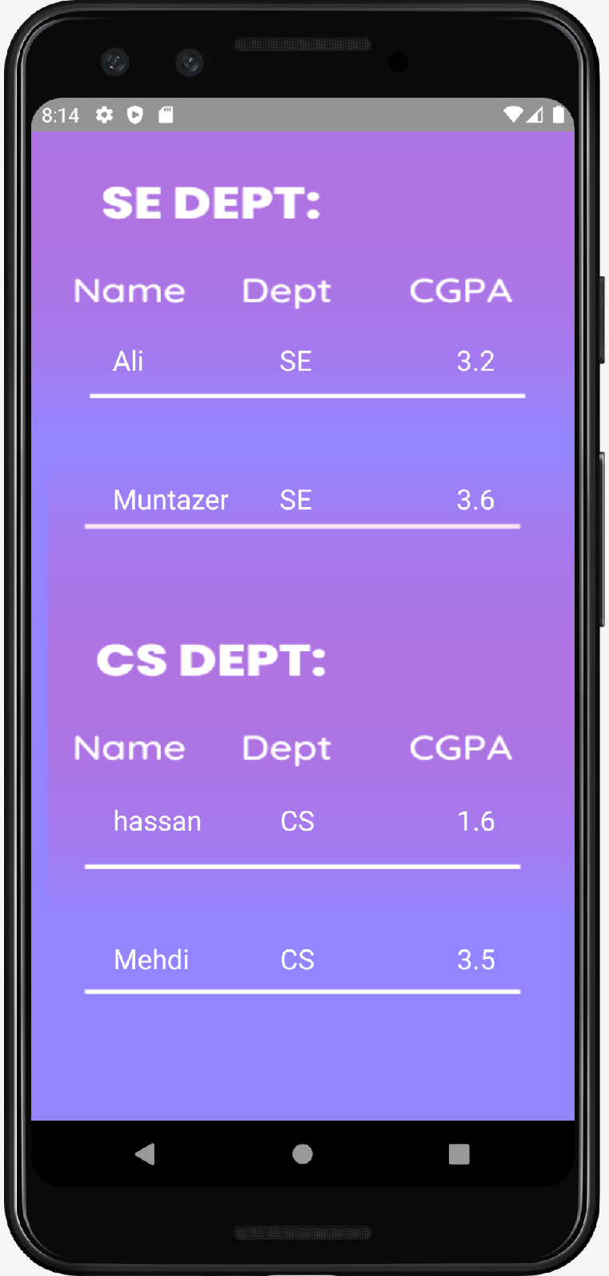

**Main Output**

**Insert:**

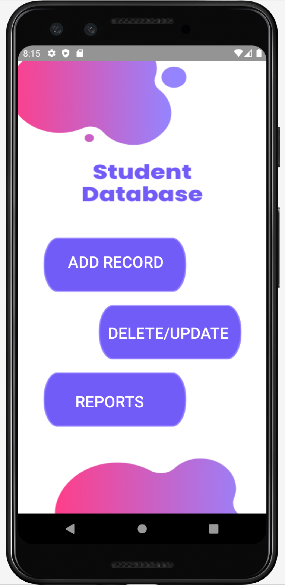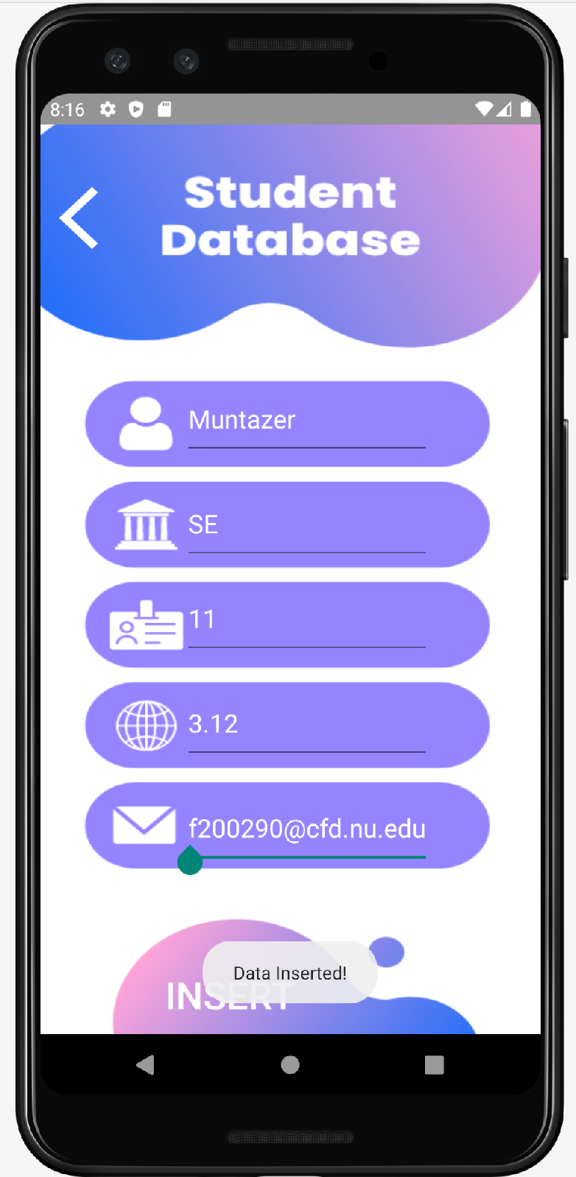

**Update:**

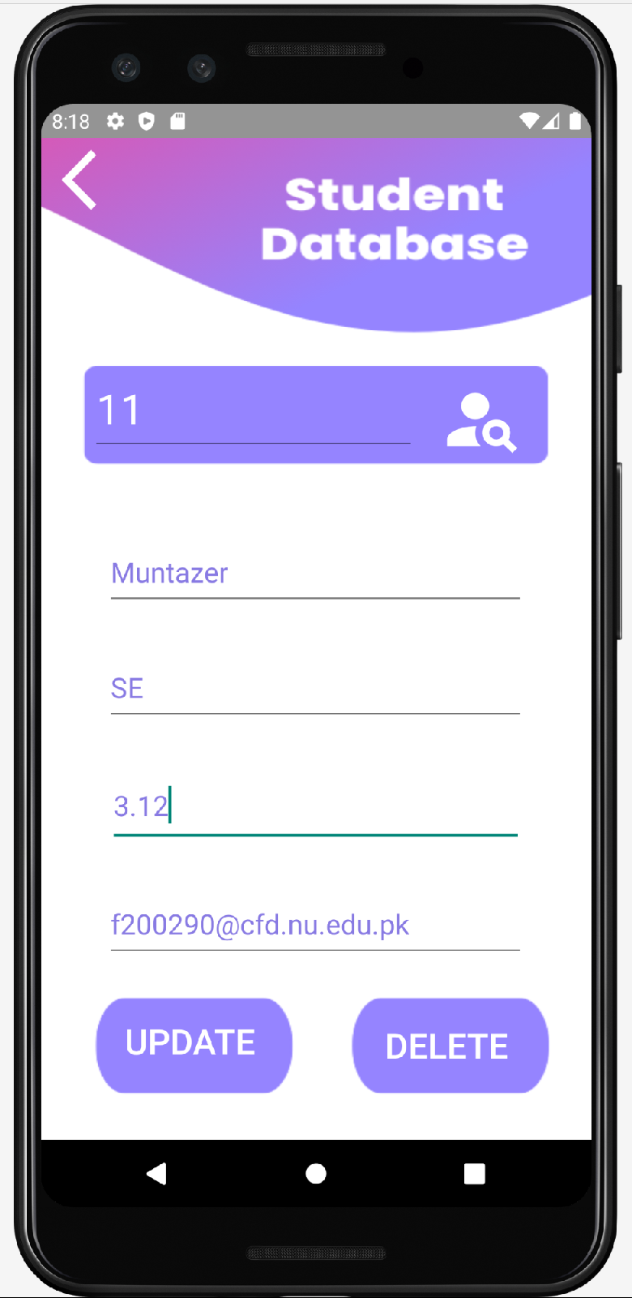

**Delete:**

**Reg NO: 11 Deleted**

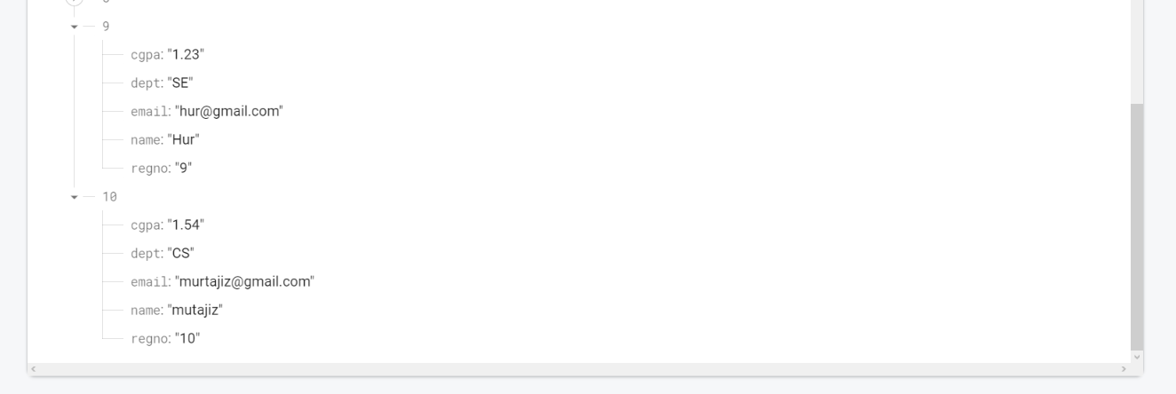

**Reports:**

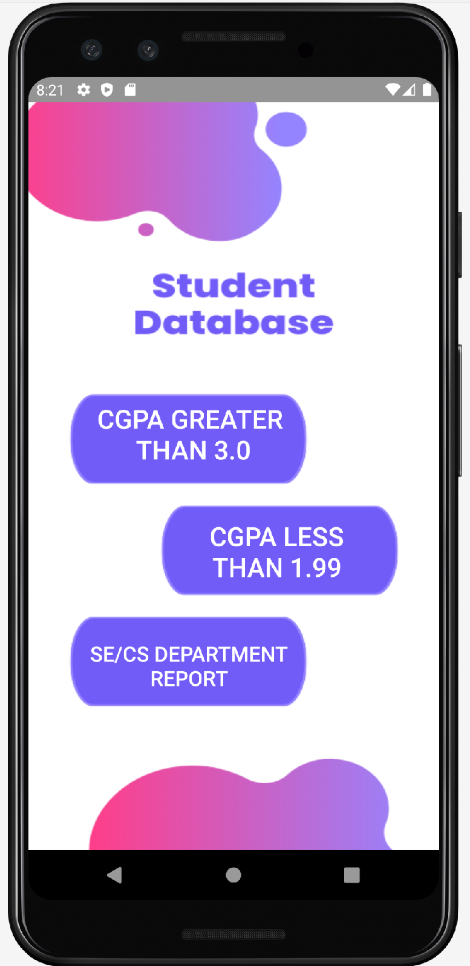

**CGPA Greater than 3.0 & less than 1.99**

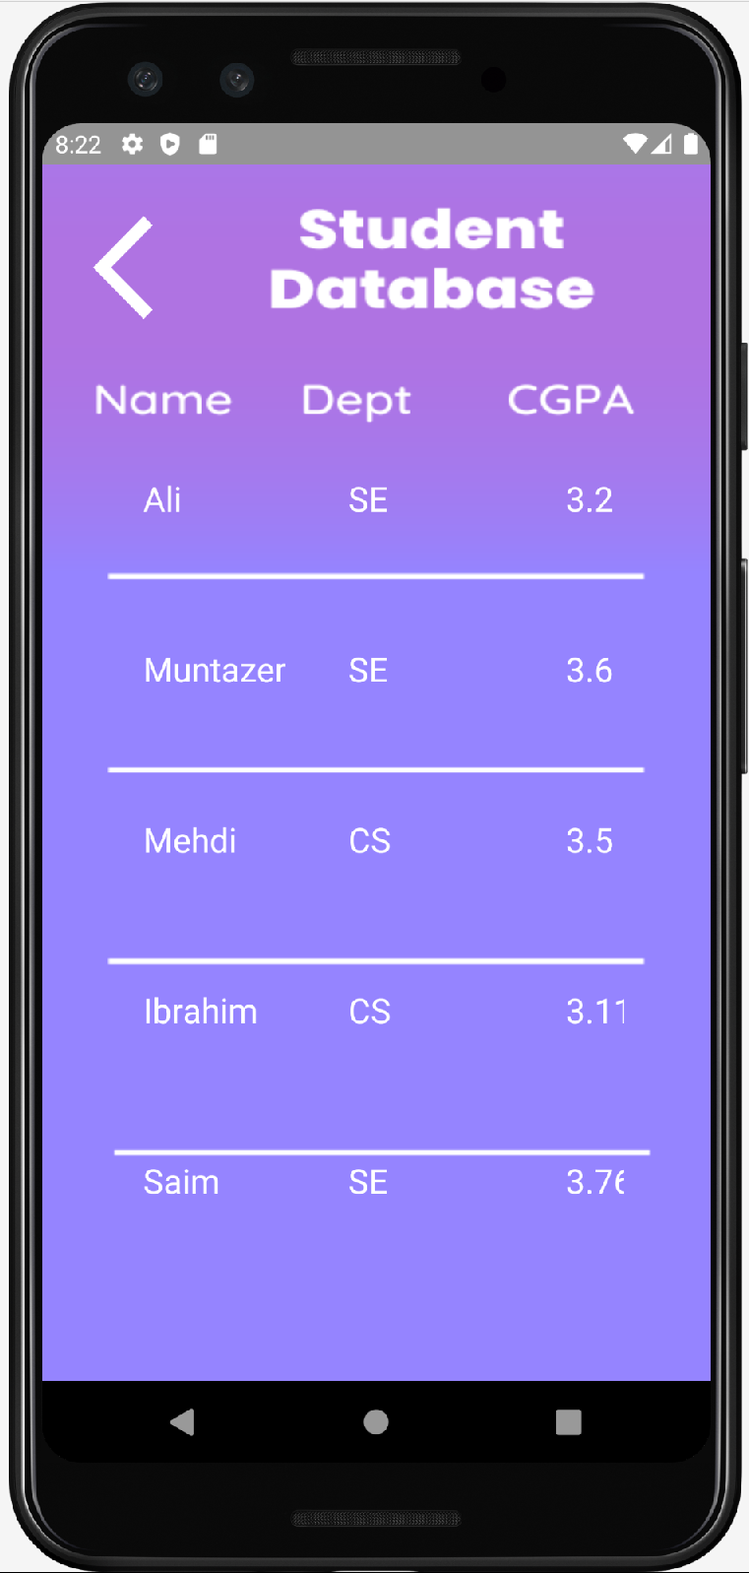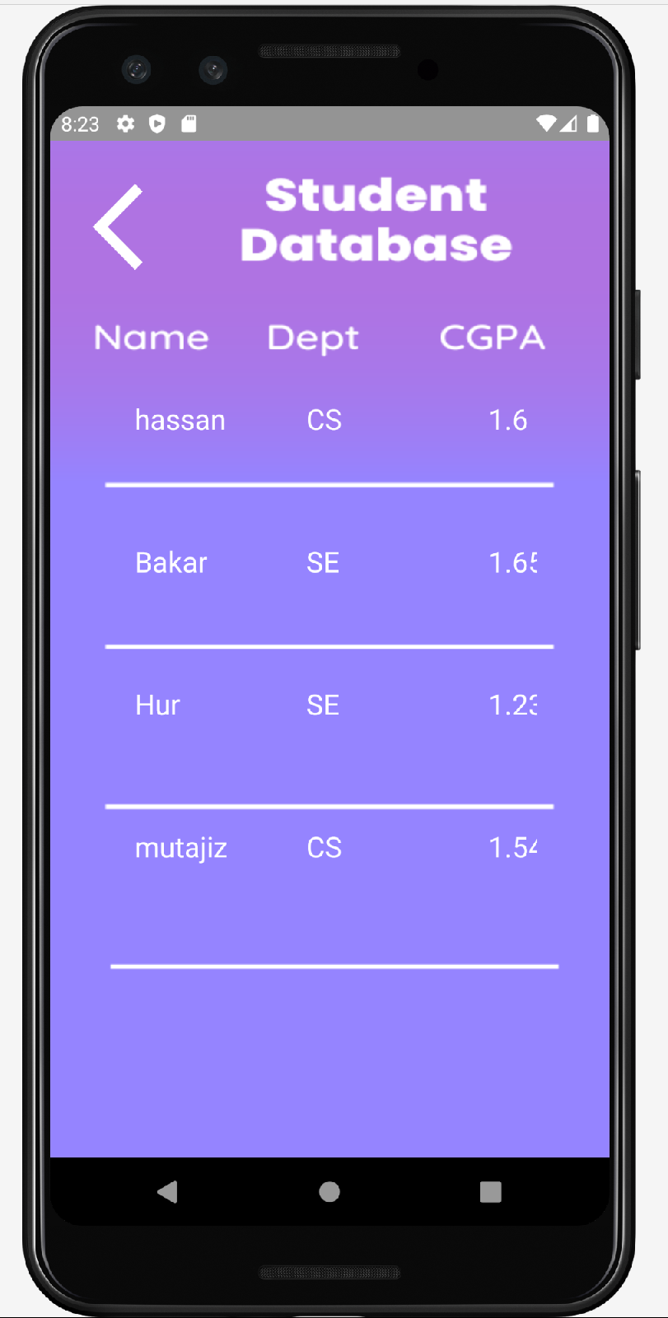

**Check Dept CS/SE:**

